Wound Care at Home

When caring for your wound at home, it is important to prevent and recognise early signs of infection

What you will need:

- Dressing pack - will include gauze, gloves, apron and waste bag
- wound dressings given by your nurse
Primary dressing:
Secondary dressing:
- Normal Saline
- Scissor for cutting wound dressing if necessary
- Emollient: QV cream for dry skin for wounds on the legs
- Compression stocking or wraps (ReadyWrap) for venous leg ulcers

What you need to do:

- Wash your hands with soap and water thoroughly particularly in between fingers and palms of hands for at least 20 seconds.
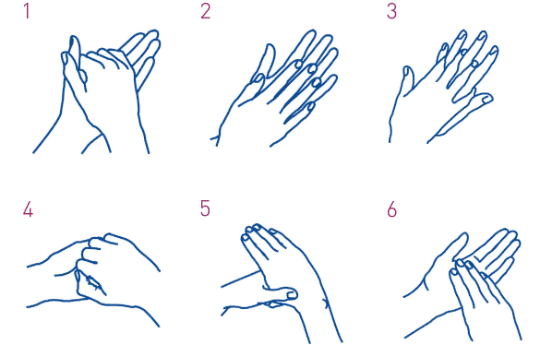
- Dry hands with a clean towel/kitchen roll.
- Open dressing pack, apply apron provided.
- Remove waste bag for dirty dressings.
- Open new wound dressings provided by your nurse and drop them into clean opened dressing pack.
*************************************************************
- With your clean hands remove dressing from wound without touching the inside of the previous dressing and the wound. If previous dressing stuck to wound, please soak it first with normal saline to ease removal, do not pull if stuck as this will damage the healing wound.
- Place this dressing into the bag provided in dressing pack.
- Wash hands again, this is very important to prevent infection.
- Apply gloves from dressing pack.
- Irrigate wounds and surrounding skin with normal saline
- Pat dry with gauze from dressing pack.
- Apply new dressings as directed by your nurse
- Seal and dispose of the waste bag appropriately into your domestic waste bin
- Renew dressings at least twice a week.

Additional things to do:
- Take a photo at least once a week or if noticed if there is any signs of deterioration or infection.

References: https://www.gov.uk/government/publications/wuhan-novel-coronavirus-infection-prevention-and-control
https://www.nhs.uk/live-well/healthy-body/best-way-to-wash-your-hands/

Please monitor for signs of wound infection

Observe for:

- Redness to surrounding skin of the wound; this area is warmer and painful to touch
- Wound has become painful, larger and deeper in size
- Swelling on surrounding skin
- Increased discharge from wound.
- Wound is producing offensive yellow or green discharge or is bleeding.

If you suspect a wound infection please contact your GP practice telephone number:

